1. Use the existing server or create new server

* For creating new server:

Go to SQL 2022 Installation Center -> Installation -> New SQL server (1st option)

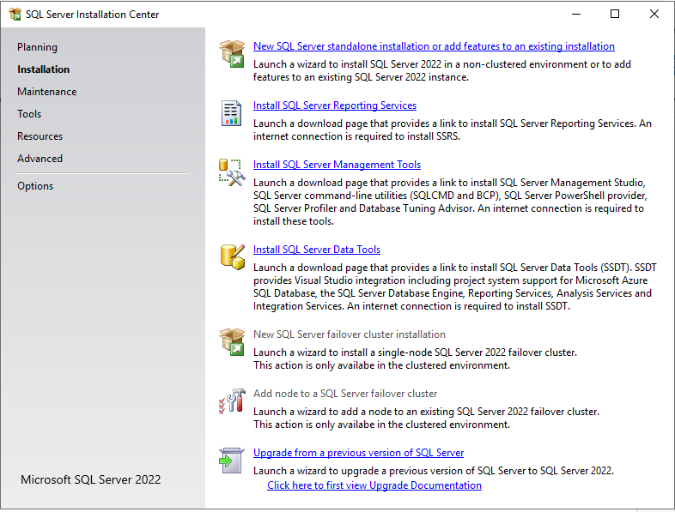Choose the C:\SQL 2022\Developer ENU file for installation

1. After setting up server, login with the windows authentication and create a database name BakeryOrderSystem.

* Can run all the queries file in the one drive Create table -> Insert Value

1. To connect to the web:
2. To create a user using “Create User.sql”
3. Set the database to **windows authentication and sql user authentication.** (This is important or else the web cant login to the server)
4. In the config.php:  
   $serverName= "MYSERVER\ASSIGNMENT"; #change to your server name

$connectionInfo= array("Database"=>"BakeryOrderSystem", "UID"=>"bakery_user", "PWD"=>"StrongPassword123!"); #change to the user that you created

4. Run Xamp and open the login.php

If got error:

Fatal error: Uncaught Error: Call to undefined function sqlsrv_connect() in C:\xampp\htdocs\Cloud_Sec\config.php:4 Stack trace: #0 C:\xampp\htdocs\Cloud_Sec\login.php(2): require() #1 {main} thrown in C:\xampp\htdocs\Cloud_Sec\config.php on line 4

1. Download driver on: <https://learn.microsoft.com/en-us/sql/connect/php/download-drivers-php-sql-server?view=sql-server-ver16>
2. Copy these files to C:\xampp\php\ext:

* php_sqlsrv_81_ts_x64.dll (example for PHP 8.1 Thread Safe x64)
* php_pdo_sqlsrv_81_ts_x64.dll

1. Edit php.ini to add:

extension=sqlsrv_81_ts_x64   
extension=pdo_sqlsrv_81_ts_x64

Then run the xamp again :)))

* If the got login error, try to use the ssms to login to the newly created user (“UID"=>"bakery_user", "PWD"=>"StrongPassword123!”)
* Got error again? Restart!!!!

Tables:

